MASCHERPA Audric ROB 3 2022 / 2023

**POLY-SNAKE**

**Meeting report n°3 from 28/10/22 :**

Figure 3.1

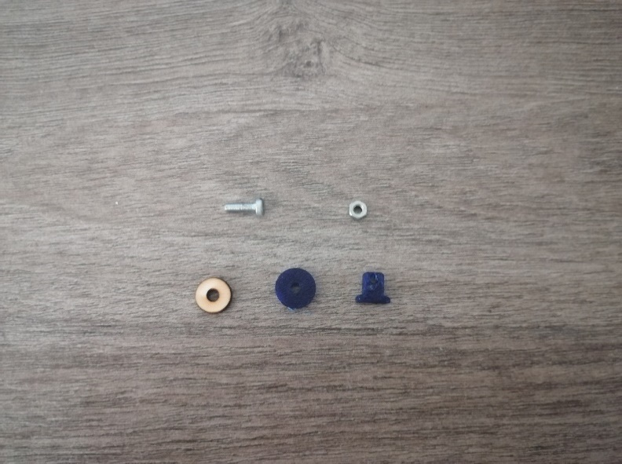During this third session, I worked on modifying some details of the 3D part modeling. Indeed, I increased the size of the place reserved for the servomotors which was too small as well as other small design details. In addition, I decided during this session to add wheels to allow the system to be able to slide on the ground. So, in order to find the ideal diameter, I first made the wooden wheels (Figure 3.1) with a laser cutting machine in order to find the ideal diameter of the wheels.

Then once the diameter (13mm) was chosen I was able to launch the 3D printing of the wheels as well as their supports which will be connected by a screw and a nut (the goal being for the moment to allow the robot to slide on the floor).

Figure 3.2

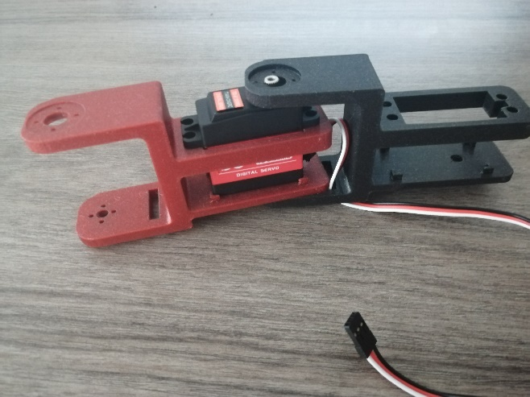Then I was able, thanks to the part printed in 3D last week and the one printed during the course, to make an assembly of a Poly-Snake module as we can see in the figure 3.2.

Finally, we can see in the Figure 3.3 the current 3D model of the piece. The next session will therefore be devoted to the modification of a few slight details and the pooling of my work as well as that of my partner (who for his part had to carry out the programming of the movement of the snake) in order to test the fluidity of the gestures of the system and the proper functioning of the robot.

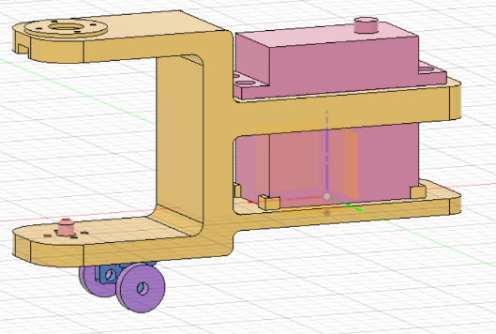

Figure 3.3